Electronic Funds Transfer (EFT)
# Source: AI Source: Provided by: [Data Path: Persons Table -> ID Column: 1, Name_En Column: Motasem Essam] -> From: [Chatgpt (GPT‑5 Mini)] on [1/21/2026]
Electronic Funds Transfer (EFT) refers to the digital movement of money from one bank account to another using electronic systems — without the need for paper documents, cheques, or physical cash. It is the foundation of most modern banking transactions, including direct deposits, ATM withdrawals, and online payments.

🧠 Simple Definition
# Source: AI Source: Provided by: [Data Path: Persons Table -> ID Column: 1, Name_En Column: Motasem Essam] -> From: [Chatgpt (GPT‑5 Mini)] on [1/21/2026]
EFT is any computer-based system that allows money to be transferred between accounts electronically, either within the same bank or between different banks.

🔁 How EFT Works (Basic Flow)
# Source: AI Source: Provided by: [Data Path: Persons Table -> ID Column: 1, Name_En Column: Motasem Essam] -> From: [Chatgpt (GPT‑5 Mini)] on [1/21/2026]
- You initiate a transaction — e.g., online transfer, card payment, bill payment.
- Your bank or payment service generates an electronic instruction.
- The instruction is sent through an EFT network (like ACH or SWIFT).
- The recipient bank credits the destination account, and settlement occurs (real-time or deferred).

💼 Common Types of EFT Transactions
# Source: AI Source: Provided by: [Data Path: Persons Table -> ID Column: 1, Name_En Column: Motasem Essam] -> From: [Chatgpt (GPT‑5 Mini)] on [1/21/2026]
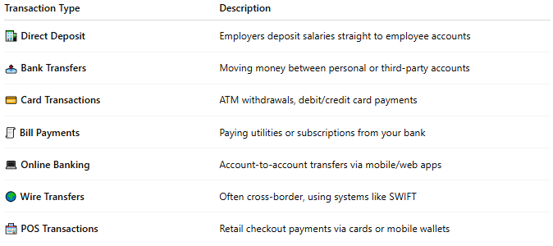

Transaction Type | Description
🏦 Direct Deposit | Employers deposit salaries straight to employee accounts
📤 Bank Transfers | Moving money between personal or third-party accounts
💳 Card Transactions | ATM withdrawals, debit/credit card payments
🧾 Bill Payments | Paying utilities or subscriptions from your bank
💻 Online Banking | Account-to-account transfers via mobile/web apps
🌍 Wire Transfers | Often cross-border, using systems like SWIFT
🏪 POS Transactions | Retail checkout payments via cards or mobile wallets

🌐 EFT Networks Examples
# Source: AI Source: Provided by: [Data Path: Persons Table -> ID Column: 1, Name_En Column: Motasem Essam] -> From: [Chatgpt (GPT‑5 Mini)] on [1/21/2026]
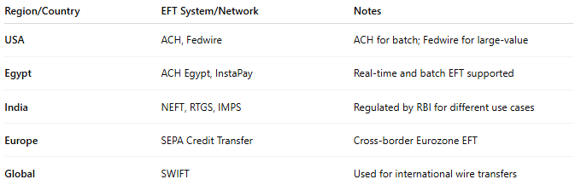

Region/Country | EFT System/Network | Notes
USA | ACH, Fedwire | ACH for batch; Fedwire for large-value
Egypt | ACH Egypt, InstaPay | Real-time and batch EFT supported
India | NEFT, RTGS, IMPS | Regulated by RBI for different use cases
Europe | SEPA Credit Transfer | Cross-border Eurozone EFT
Global | SWIFT | Used for international wire transfers

✅ Advantages of EFT
# Source: AI Source: Provided by: [Data Path: Persons Table -> ID Column: 1, Name_En Column: Motasem Essam] -> From: [Chatgpt (GPT‑5 Mini)] on [1/21/2026]
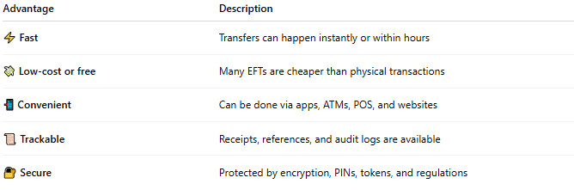

Advantage | Description
⚡ Fast | Transfers can happen instantly or within hours
💸 Low-cost or free | Many EFTs are cheaper than physical transactions
📲 Convenient | Can be done via apps, ATMs, POS, and websites
📜 Trackable | Receipts, references, and audit logs are available
🔐 Secure | Protected by encryption, PINs, tokens, and regulations

⚠️ Considerations
# Source: AI Source: Provided by: [Data Path: Persons Table -> ID Column: 1, Name_En Column: Motasem Essam] -> From: [Chatgpt (GPT‑5 Mini)] on [1/21/2026]
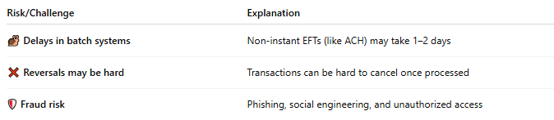

Risk/Challenge | Explanation
🐌 Delays in batch systems | Non-instant EFTs (like ACH) may take 1–2 days
❌ Reversals may be hard | Transactions can be hard to cancel once processed
🛡️ Fraud risk | Phishing, social engineering, and unauthorized access

🧠 Summary
# Source: AI Source: Provided by: [Data Path: Persons Table -> ID Column: 1, Name_En Column: Motasem Essam] -> From: [Chatgpt (GPT‑5 Mini)] on [1/21/2026]
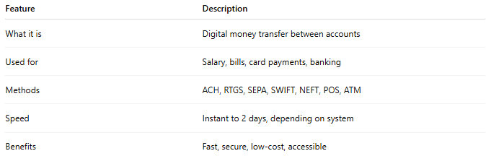

Feature | Description
What it is | Digital money transfer between accounts
Used for | Salary, bills, card payments, banking
Methods | ACH, RTGS, SEPA, SWIFT, NEFT, POS, ATM
Speed | Instant to 2 days, depending on system
Benefits | Fast, secure, low-cost, accessible

